Lab: SOLID
- Stream Progress Info
Refactor code for this task, so Stream Progress Info can work with different kinds of Streams. First make sure it works with Music too. Refactor code, so in the future if a new kind of stream is introduced, you will need just to import one new class with BytesSent and Length getters in it.
- Graphic Editor
Refactor code for this task, so Graphic Editor can draw all kind of shapes without checking, what kind is concrete shape. In the future new shapes will be added to system, so prepare the system for this moments. When you add new shape, you just should add new class and nothing more.
- Detail Printer
Refactor code for this task, so Detail Printer don’t need to ask what kind of employee is passed to it. Detail Printer need just to print details for all kind of employees. When new kind of employee is added you will need just to add new class and nothing else.
- Recharge
You are given a library with the following classes
Worker implements ISleeper
Employee inherits Worker
Robot inherits Worker
RechargeStation
If you inspect the code, you can see that some of the classes have methods that they can't use (throw UnsupportedOpperationException) which is clear indication that the code should be refactored.
Refactor the structure so that it conforms to the Interface Segregation principle.
Hints
Make the Robot to extend Worker and at the same time to implement Rechargeable
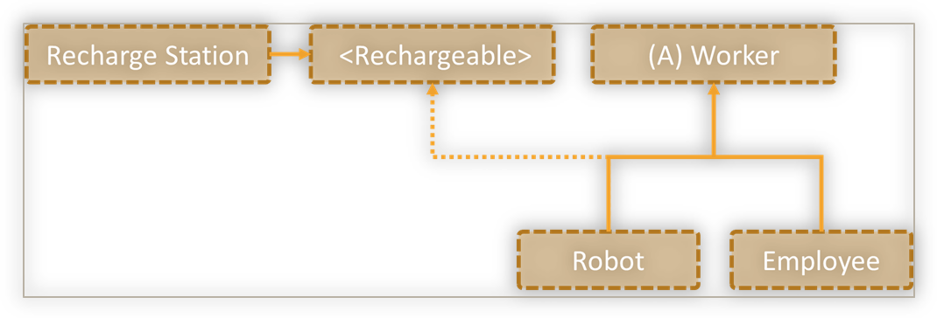

- Security Door
You are given:
SecurityManager
abstract class SecurityCheck
interface SecurityUI
SecurityManager which can interact with a user by validating his key card or by getting his pin code. Both methods are provided by an interface called SecurityUI. The validation is performed by the appropriate SecurityCheck class.
Refactor the structure so that it conforms to the Interface Segregation principle.
Hints
Split SecurityUI into smaller role interfaces, one for each SecurityCheck class
